Assignment 3   
Introduction to Information Technology

Personal Information --------------------------------------------------------------------------- 1  
Team Profile --------------------------------------------------------------------------------------- 3  
Ideal Jobs ------------------------------------------------------------------------------------------- 8  
Tools ------------------------------------------------------------------------------------------------- 8  
Industry Data ------------------------------------------------------------------------------------- 2  
IT Work ---------------------------------------------------------------------------------------------- 2  
IT Technologies ----------------------------------------------------------------------------------- 2  
Project ---------------------------------------------------------------------------------------------- 2  
Reflection ------------------------------------------------------------------------------------------ 2

Us —

**We are a symbiosis of devout problem-solvers, creative savants and alpha-geek developers with a unified goal–to deliver a simple translation solution to the palm of your hand. UMI marries linguistic rights with cutting edge technology to empower people of all language backgrounds around the world.**

Our Mission

To disrupt longstanding language barriers in the hospitality industry & provoke a paradigm shift in the way we interact in ordinary exchanges.

Our Vision

Realising the full potential of language translation for hospitality businesses and individuals. A world where everybody has access to a meaningful dining experience, not just those who speak the native language.

Team Profile —

Daniel Blake  
I’m Daniel Blake (s3910924) of UMI. I’m from an English background but moved to Australia at a young age. I love AFL and the west coast Eagles. I also spend a lot of time camping, fishing, and at the beach. My professional background is in Operational Technology and Vehicle Automation specific to the resources sector. My interest in IT is to expand my knowledge and career opportunities in mining or other industrial technology fields. Go UMI!!!

Nicholas Drinkwater   
Hey! I’m Nick Drinkwater (s3508178) of UMI. I was born in Sydney but grew up in Melbourne. Whilst I don’t have any formal IT experience, I actually previously started this degree back in 2015. After completing half a year, I left to go traveling, spending 2 years living in Edinburgh, Scotland.

With Coronavirus and being unable to travel, I decided to use this time to return and finish my degree! I love traveling, film, and baseball. My interests in IT include programming, building IT systems, and hardware. I hope to learn the necessary skills and knowledge to help me enter the IT industry in my career, as well as exposure to inspiring topics and fields of IT that I haven’t seen or encountered before.

Abby Durbridge  
I’m Abby Durbridge (s3794613) of UMI– a Melbourne resident living in the heart of Southbank and loving every moment.  My passions lie in creative arts and languages and use most of my spare time growing my skills in each. Historically, I’ve worked with an Engineering firm before transitioning into a SaaS company within the Childcare Industry. A hefty lockdown saw me trying to develop new skills and interests and evidently picking up another degree. My interest in IT hasn’t been at the forefront of my life but rather a natural necessity, and it wasn’t until I began to think of developing my own software or being able to work remotely for any company that I pursued IT professionally.

Mathew Dwyer  
My name is Mathew Dwyer (sS3807459) of UMI. I’m 27 years old and based in Newcastle, NSW. English is my primary language, however I’m in the process of learning German. Previously, I’ve completed 3 semesters of a Bachelor of Communications at University of Newcastle, as well as partially completed a video game course through TAFE. I love playing with electronics and am currently expanding my skills with 3D printing, 3D modelling and CAD to facilitate the printing of miniatures and terrain for my DnD games.

My experience in IT is specific to web development and electronics, having played an integral role in the development and ongoing maintenance of the website of a retail store I worked for. Additionally, I’ve had involvement in video game development and have created several small games for various competitions. Software development, automation and cybersecurity are all areas I’d like to explore during the course of my education and career.

Erin Paton

I’m Erin (s3910930) of UMI. Originally from Sydney, I relocated to Byron Bay for a change of pace and to get closer to nature - most of my weekends are now spent hiking, exploring waterfalls, or at the beach. Currently, I’m fluent in English but I have a passion for French culture and intend to study the language up to C-level (only after I’ve knocked over a few programming languages!).

My experience with IT is specific to marketing technology, and the software used to implement it. Art, Design, Psychology, Health & Wellness, and Sexual Education are all areas that are important to me and while I don’t have plans to further my education in these fields, the possibility of exploring their convergence with emerging technologies is something that excites me. I’d love to play a role in increasing the accessibility and interoperability of these spaces in some way throughout the course of my career.

Harrison Tang  
My name is Harrison Tang, s3908223 of Team UMI. Born to migrant Chinese parents, I am a second-generation Australian and denizen of Brisbane Town/Meanjin. Whilst not possessing an extensive background in IT, I grew up in the 1990’s and 2000’s playing video games and exploring the internet. Eventually, technologies would play a crucial part in my life in staying connected with friends and family, discovering art and music, educating and expressing myself, and seeking new employment and career opportunities. Recent work performing administration and data collection for an infrastructure company prompted an exploration into avenues in programming, cloud services, and app and web design leading to pursuing a formal education in IT. Currently, I play guitar as part of the ‘strings’ section in a ten-member pop-punk cover band/orchestra and occasionally travel interstate to perform.

**Group Processes**

Retrospectively, working as a group went exceptionally well for UMI and we felt that the entire team contributed equally and consistently during Assignment 2. We were pleasantly surprised to observe that the team's commitment, motivation, and participation throughout the project was consistently high, which afforded the team peace of mind and confidence in one another.

This observation is especially true considering the majority of the team initially entered the collaborative environment with apprehensions about the possibility of workload disparities, confrontations and roadblocks. These assumptions were due to previous encounters with substandard teamwork experiences. We were fortunate enough to find ourselves in a group of self-starters, all of whom demonstrated a fair disposition and an openness to suggestions and constructive criticism.

While our group worked exceptionally well together, we still identified areas for improvement moving forward and we have strived to integrate the learnings from these experiences into Assignment 3. These areas of improvement include more structure around individual deadlines - we often found the agreed upon due dates were generally not adhered to, making subsequent meetings more lengthy and more discussion required around how individuals were tracking. The team implemented harder deadlines to mitigate this issue, enabling a more transparent overview of progress and allowing more time to collaborate across various tasks.

Additionally, we learned that our quality control processes were far less efficient than intended, with excessive editing required to ensure the written elements of the assignment were palatable for readers of all technical understanding and to achieve a consistent tone of voice across the project. To reduce this load, the team devised an improved QC process that required more stringent checks of one's individual work preceding QC submission. With a few added steps marked off using a templated checklist, we aimed to prevent the rewriting of significant segments and free up the quality controller's time for more technical tasks. Subsequently, QC editing was focused primarily on minor spelling and grammar issues, plus some minor tweaks to maintain continuity of tone. Additionally, multiple team members were introduced to the QC process to prevent the inundation of work to any one team member.

We also concluded that more contribution from the entire team to GitHub would provide greater insight into our progress along the way. We found that we failed to form this habit in the early stages of Assignment 2, which was frequently overlooked or left to one team member. Consequently, the team emphasised the importance of GitHub and committed to utilising it more frequently to generate an audit trail of our work.

**Career Plans**

Auditory  
  
Tools —

**Group Website  
ADD IN LINK**

**Group GitHub Repository**  
github.com/blakey83/Intro-to-IT---assignment-2

**Individual Websites**

s3910930.github.io/erinpaton/home.html  
aabbayy.github.io/space-junk/  
harrisontang.github.io/Assignment1MyProfile/  
drinkwatern.github.io/IIT/index.html  
matdwyer94.github.io/COSC2196-Assignment-1/  
blakey83.github.io/

**What We’ve Done**

From the outset of our assignment, we wanted to ensure that we could track and maintain all of our objectives and the output that was produced. We therefore set up a group GitHub to house all artefacts created, such as our report and website. We opted to use Google Docs to work on our report, which enabled us to work collaboratively and monitor contributions in real-time. Using a collaborative platform rather than a Word file removed the need to continually download documents and upload them to GitHub whenever changes were made. To track these changes, we uploaded a Word file version of the Google Doc to GitHub periodically.

We used Microsoft Teams extensively for all of our group communication and meetings. Kanban was chosen as the most effective collaborative framework to track each individual's work and we opted for Trello to effectuate this, which has proven invaluable for our team, particularly due to its integration with MS Teams. Trello is a workflow tool that manages project tasks into a visual board. This enabled us to set appropriate deadlines for each job to be completed with transparency around each team members progress. Our workflow, broken down into columns, transpired as follows; To-Do, In Progress, Staging, Ready for Production, Completed. Each task had a designated card that was assigned an owner. The card would then visibly make its way through the workflow in real-time. Once a card reached completion, its content was committed to the website and the final report.

Additionally, UMI utilised Miro, an online collaborative whiteboard, to facilitate brainstorming for our project idea.

**MS Teams Information**

**Meeting 1**web.microsoftstream.com/video/f0ca4da0-da26-429e-80f2-61502974de3c

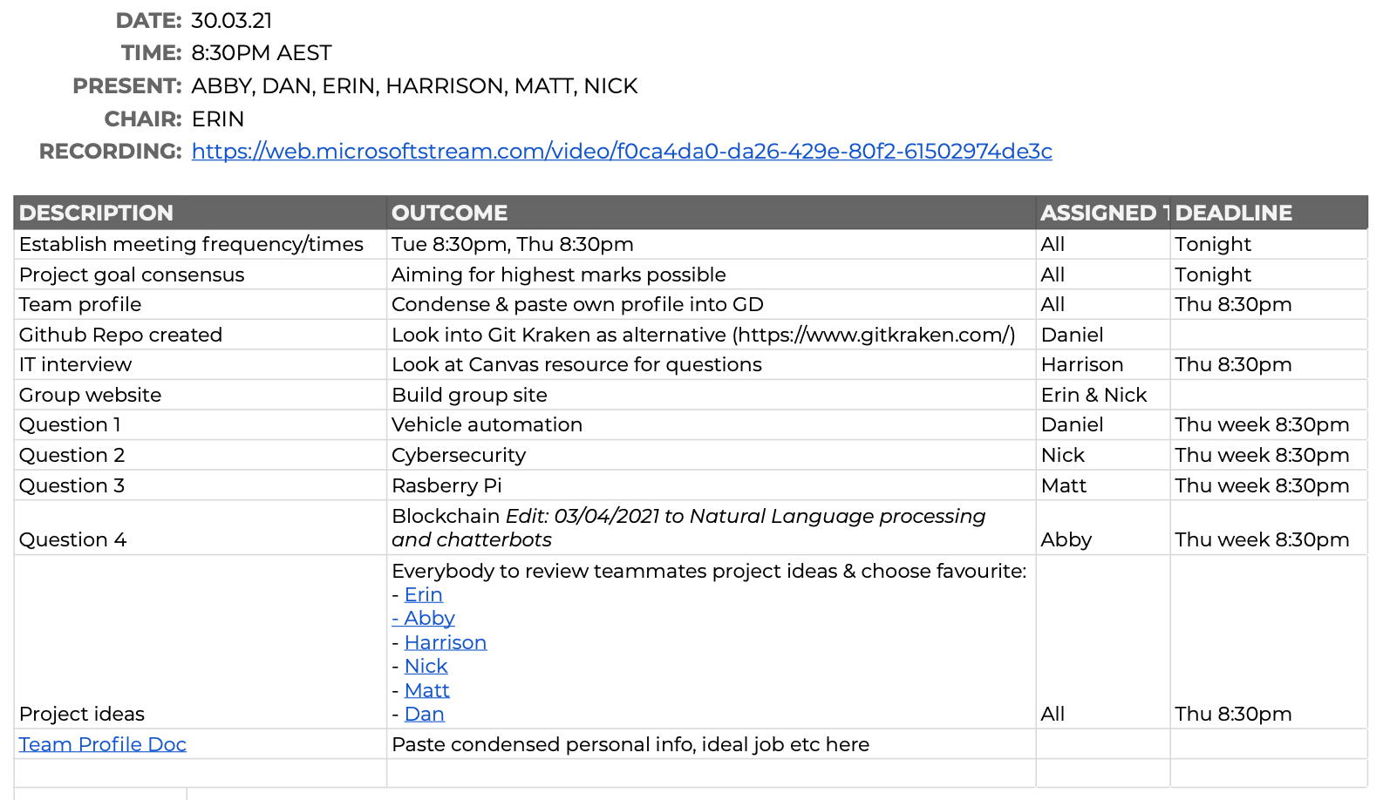

**Meeting 2**

**Meeting 3**

**Meeting 4**

**Meeting 5**

Project Overview—  
Topic  
UMI is a

Motivation  
UMI is a

Landscape

UMI is a

Project Description—  
  
Aims  
Our project aims to have a market-ready translation application to be used in restaurants around the world. To achieve this, we have broken up our project into 4 phases. Each phase will have goals and deliverables required to pass to the next phase.

Phase 1 was the planning phase, where we decided on an application and investigated the tools and technology to deliver it. Phase 2 is the sales phase. We are refining our application based on feedback, creating a video outlining the business objectives, and creating deliverables that ensure our product looks marketable. Phase 3 is the prototype phase, in which we will secure the infrastructure needed to build the app, write the code and create a working application—one that can translate! Finally, phase 4 is the test and release phase. We will beta test the prototype during this phase and receive feedback on improvements and bugs in the software. Beyond this, we will begin marketing the product, releasing a limited number of preview versions, and establishing a continuous improvement model to ensure that the app is as good as it can be when released on 8th February 2022.

**Phase 1: Ends 23rd April 2021**

Our first goal for phase 1 was to produce a comprehensive written report including a complete description of the application, the motivations behind it, and the tools and technology needed to bring it to life. The report will ensure that we have all the relevant information in one place to move to phase 2 of our plan.

Another phase 1 goal is to have a functional website dedicated to the project. This website will reflect the information contained in the report. The website is an essential step in our project, as it allows us to share our ideas with the world, bring on investors, and be our first steps in marketing the product.

**Phase 2: Ends 28th May 2021**

In phase 2, the first goal is to write up a second report. This report will provide more nuance and detail regarding the planned operation and incorporation of feedback received during the rollout of the phase 1 report. This report is crucial as it allows us to refine our plans and our product and demonstrate significant growth in the project.

We will produce an informational video for the completion of phase 2. The video will include a description of the application, its motivations and objectives, and how our application differentiates from other translation services. The video is an important marketing tool and is available to send out to investors and other relevant stakeholders.

Phase 2 will require the team to create a model of how the application will look on a user's device. The process will involve using Figma to provide an interactive interface prototype. The model is another critical step in showing relevant stakeholders and potential customers how the app will look and feel upon release.

**Phase 3: Ends 6th August 2021**

The primary goal for phase 3 will be to have a working prototype by completion. The process will involve procuring the needed infrastructure and completing the development to run working translations. Prototype completion is crucial as we need the application to function adequately to begin testing and further secure funding for testing and marketing.

**Phase 4: Ends 8th February 2022**

By the end of phase 4, we will need to have a tested and working application ready for market. We will need to complete beta testing and fix any bugs or issues to ensure we can launch the application at a professional standard. Market launch is essential, as we will need to start generating income beyond the launch to pay back investors and ourselves.

By the end of phase 4 of the project, we should have a comprehensive ongoing marketing plan. Marketing will involve having detailed digital marketing strategies and ongoing customer engagement. After launch, we must know how we will grow the business and have documented plans to showcase our application to the world.

Our final goal for the end of phase 4 is to institute a continuous improvement plan. Continuous improvement ensures that all customer feedback can be stored, collated, and acted upon promptly. This is important as our application exists in a competitive landscape, and continuous improvement is the only way we can stay ahead of any potential future competitors.

Plans and Progress  
On the 30th of March 2021, six total strangers met online for the first time. We came together to investigate careers in IT, learn about technology and conceive a viable IT project idea. With six diverse ideas on the table, we decided that the most feasible option was a language translation application that allows written translation from one web-enabled device to another using near field communication (NFC). Our application was to be called UMI.

**Early Plans**

The first iteration of our project was a language translation application that could translate messages between people using Near Field communications. Customers would download the application onto their mobile devices and exchange messages to communicate across language barriers. Our early design work involved having an application available for both Android and Apple but using a standard back-end design.

The end-user will download the application onto their device (or load the web page if on a computer), where the application will prompt them to log in or create a new account. Once logged in, the user can submit text or documents they wish to translate into another language.

The application will send uploaded documents to the webserver through the Hypertext transfer protocol (HTTP) server. The web server will then send the documents to the application server, converting, via an API, into SQL data stored onto the user database.

The application will then convert the document into text and send it to the NMT server to translate. The NMT server will use wordnet databases in both the original and target language. The translated text will then return to the application server to convert back into a document. It will be stored on the user database and will be available to the user for future use.

The user can then share the message with anyone they wish, in any language they wish. In addition, the app supports the use of Near Field Communication (NFC) to exchange information between users. So, for example, if a user has a document or message they wish to share with another user in a different language, they can submit the original document to the app and then share a link to the second user through NFC. The second user will send a request to the application server, which pulls the original text, passing it to the NMT server for translation. The translated text is subsequently returned to the second user via the web server HTTP link to their device.

However, after conducting preliminary primary market research (interviewing family, friends, and co-workers), it was concluded that requiring strangers to tap their phones together in circumstances where they could not communicate would be difficult. There are both real and perceived security threats; the theft of data and cultural misunderstandings would make things particularly difficult. The group decided this would not be a marketable product in the real world.

**UMI 2.0**

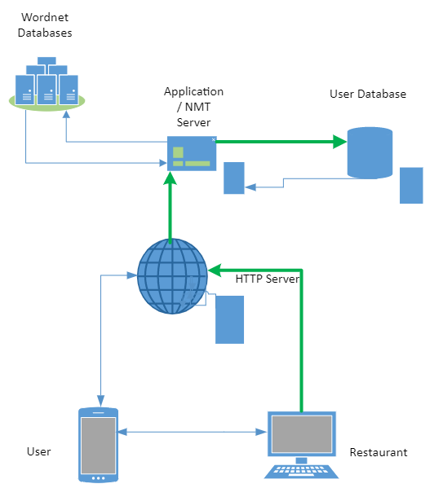The team unanimously concluded that the original idea would need to pivot to create a marketable solution. The group met and floated many ideas, including weighing the possibility of entirely changing the project idea. Nevertheless, the group decided that the original idea, although flawed, had merit, not to mention the considerable research and work the team had invested into this idea. After some collective spit balling, the team decided to proceed with an idea to modify the app to service the hospitality industry. The assumption was that a customer who does not speak the language of a particular restaurant would have a significantly better dining experience if they could instantly translate menu information with a simple tap of their phone. The team hypothesised that the customer would download the venue's menu by tapping their mobile device onto an NFC reader installed at the restaurant with the translated menu being transmitted to their phone. The customer would subsequently return their order to the restaurant with any notes or changes, with the application translating the text back into the language of the restaurant.

This pivot requires us to make changes to the front-end design. These include making the app more geared toward a web browser model for restaurants, ensuring that our product could fit into existing infrastructure, and investigating NFC readers that would work on USB. Our approach was now to have two distinct functionalities: downloading a menu and making an order.

Restauranteurs will need access to a computer connected to the worldwide web to log into our HTML web page. From here, they can upload menus, show previous orders, and, most importantly, ensure the customer's billing details are up to date. First, the restaurant client will upload the menu to the

HTTP server, which passes it to the Application server, who then converts it to the SQL format and stores it on the Client database.

The restaurant customer will open the application on their NFC-enabled device and then tapping their phone onto the NFC device installed at the restaurant's counter. A request will then be sent through the webserver to the application server to retrieve the restaurant's menu. Next, the text will be sent, along with the user's language information, to the Neuro Machine translation (NMT) server. The NMT server will then use the NMT algorithm to choose words from the user's language wordnet database to translate the menu into the user's language. Finally, the app will send a translation to the user via the HTTP server.

**Component Details**

*Front End Development*

The front end is the user interface, usually a web page for the restaurant user or through an app on their phone for the customer. Once signed in, the user has a landing screen. From here, they can see their account information in their language. Once the customer requests a menu, a translated version of the menu will be made available. Translation can be completed automatically through the app, with the preferred method being a data transfer via near field communication (NFC). Once the device has tapped the NFC hotspot, it will connect to the app's web server and download the menu in the language of the user's choice.

The website and mobile app should be designed and developed in tandem. The development will require the X code coding suite to develop the iPhone App (Ching, 2019), Android studio for the Android version (TheZachBales, n.d.) In addition, we will create Web pages with a combination of HTML, CSS, and JavaScript (Cox, 2020).

*Near Field Communication*

Near Field Communication (NFC) devices allow the peer-to-peer transfer of secure information between two clients in the same geographical location (Sauter, 2016). Our app is about communication between a hospitality business and potential customers.

As the restaurant side would mainly be using PC or laptops already, there would be a need for them to purchase an NFC reader for around $60 (Square Reader, n.d.). To program the NFC Reader for the app, they will need to be encoded for around 25c per tag with Go-to tag encoder (Go To. n.d.)

*Web Server*

The app requires a connection to the internet to send and receive data from the client to the app's back end. Therefore, UMI needs a Hypertext transfer protocol (HTTP) connection over the world wide web that connects to the web server in the cloud (Schuler, 2002). The client can request data such as database information and photos.

After researching various options, including buying and setting up the UMI server, the team concluded that using a cloud service was preferable. Apache with the Ubuntu web server is one of the oldest and most popular HTTP server Infrastructure as a service (IAAS) products on the market (AWS 2021, a) and, as such, is the preferred option.

*Application Server, APIs and Customer Database*The application server is the real brains of the operation. It is here that the front-end makes requests for information, and the requests are processed. For example, suppose a client wishes to add a document to the database. In that case, the application server will request and add the relevant metadata to ensure the user can access the document in the future. (IT pro team, 2018).

UMI's application server will require the project to have an application programming interface (API) between the HTTP server and the Neural Machine Translation sever. Amazon offers an NMT solution and API that UMI could use. In addition, Amazon translate is a scalable solution for the product, perfect for UMI's business needs (AWS 2021, b). The project team also investigated using Microsoft Azure, which priced similarly (Azure 2021); however, the team concluded that Amazon Web Service (AWS) better suited the business growth plan.

Additionally, UMI will require an Application Programming Interface to facilitate application to customer service information and menu data, billing data, and personal preferences into a logical database system. The team decided that the best way forward was to bundle services with AWS, as they were competitive on price. Consolidating UMI's APIs and IAAS within the same company could be beneficial when looking at it from an interoperability perspective. The slash DB product creates automated APIs for relational databases (AWS 2021, c). As a result, the application can store and pull data quickly and create new features for UMI's customers.

**Project Deliverables**

So far, the project has made several plans and had numerous discussions around what it plans to achieve. The team is currently working on various deliverables to ensure a smooth transition into the project's next phase. First, the team has produced a Figma prototype so that potential investors and customers can experience the product's interface before UMI commences development. The prototype is an interactive mock-up of UMI's mobile application, with working buttons and menus.

The team has also created a professional video presentation, which will demonstrate what the application does. This video represents a further opportunity for all stakeholders, future customers and potential investors.

Other deliverables include a detailed project scope statement—The Scope of Works document. With a definite project scope, managers can easily stay on track and achieve all deadlines throughout the project life cycle (Kissflow, 2021). The project scope statement defines the limitations of the project, breaks down the work, and ensures that all stakeholders are clear on objectives (Kissflow, 2021).

**Future**

The team has divided the project into 4 phases. The first phase was to bring the group together, develop a workable idea, investigate the design, investigate the tools and technology, and put forward a detailed description of the application. During this time, the team spent time collectively investigating IT technologies, careers and creating group processes.

Phase 2, the current phase, is about refining the team's output. The team has determined key deliverables and adhered to established internal processes in achieving them. The team has refined the product with considerable research invested in uncovering ways to improve the implementation of the translation service and how to develop a working prototype in phase 3.

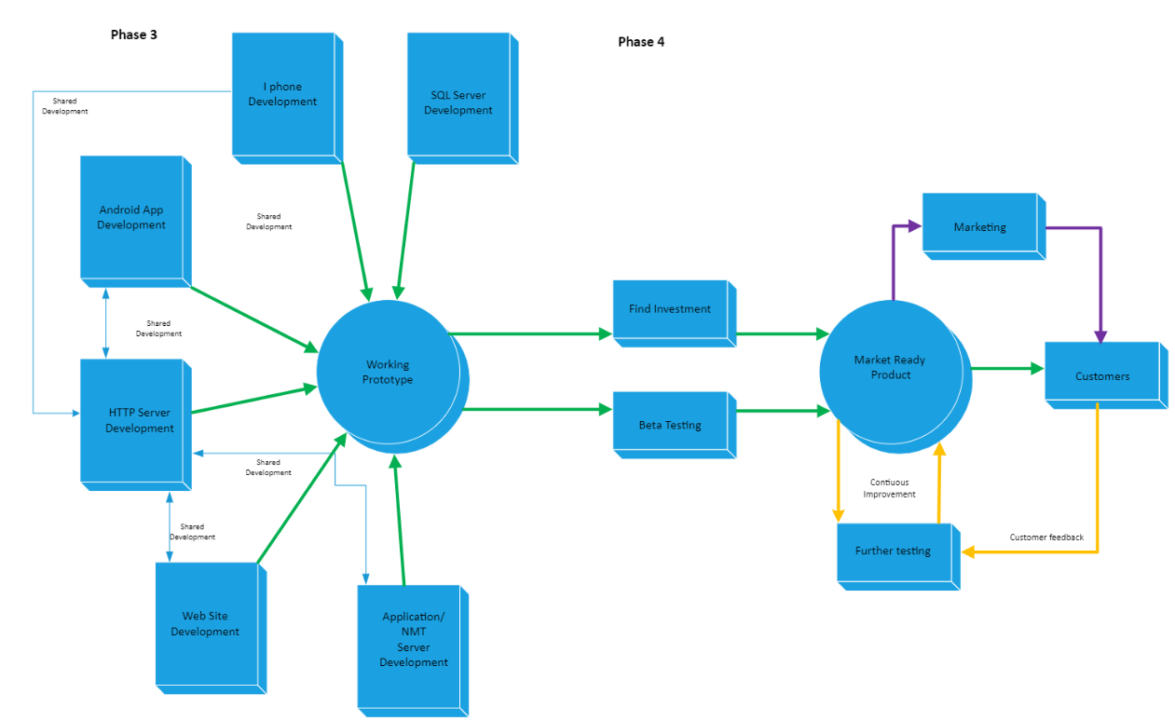

Phase 3 is primarily concerned with the creation of a working prototype. The team expects this to take place over ten weeks, from the 31st May through to 6th August 2021. The idea would be to divide up the team between the front-end and back-end development. Thus, the project would run as a series of sprints—goals for each sprint to back up the overall aim.

Phase 4 is the final stage and involves taking the working prototype and creating a market-ready product. The most crucial part of this phase is beta testing. Testing will allow the team to improve and refine the code to be the best it can be at launch. The phase will last from 8th August until a launch date that will be 8th February 2022.

Roles  
A globe

Scope and Limits  
A globe

Tools and Technologies  
A globe

Testing  
A globe

Timeframe  
A globe

Risks  
A globe

Group Processes and Communications  
A globe

Skills and Jobs —  
UMI is a

Reflection —

Daniel Blake

Nicholas Drinkwater

Abby Durbridge

Mathew Dwyer

Erin Paton

Harrison Tang

Group

Artefacts—

Figma App PrototypeUptake

Story Board and Script DraftUp

Project Scope of WorkWith today’s diverse and multicultural society, as well as ease of access to travel, language barriers can be one of the hardest things to overcome. This can be especially prevalent when trying to order or purchase something from a restaurant or other hospitality business in a foreign country. That’s why we have create UMI. UMI uses smart devices and NFC technology to help streamline the translation process and eliminate the need for cumbersome verbal interpretation.

We all have our reasons to travel, and we all share the same need to eat! We hope to break down the barriers and eliminate the sometimes nerve-wracking or anxiety inducing process of trying to purchase food in a foreign language. Wouldn’t you rather have a simple, easy way to communicate, rather than trying to play a bad game of charades or butchering the local language to the point of not being able to be understood. That is what UMI is all about. Here is how it works.

It starts by having businesses sign up for a UMI account. When a business signs up they will be taken to a merchant specific page for their place of business. From here, they can upload menu images and descriptions, view previous orders made through UMI, manage their billing details, and more.

Once a menu item has been uploaded, it will be automatically stored on our database, ready for a customer to come along and look at in their preferred language. All they would need from there is a small NFC device on their counter for their customers to tap their smart device on.

For a customer to then order from the business using UMI, they would download our UMI app from their device’s app store and login/sign up for an account. Once they are signed in, they can select their preferred language to receive information in. Using this information, when they try to access the menu of a UMI enabled business, our server will retrieve the data, and automatically translate it into the desired language using a worldwide language database. All the customer will need to do is tap their devices to the business’ NFC device and voila, instantly translated menu.

We created this app with accessibility to the mainstream consumer experiences at its core, and to advocate for a shift in cultural relatability through the experience of food and dining. UMI aims to create and connect the ties between human experiences, both familiar and unfamiliar once again.

So, come check out UMI, and unlock an easy way to experience a diverse world of food and dining experiences.

Reference Library —

**Project  
Plans and Progress**

1. Amazon Web Services, Inc. 2021. Amazon Translate Features – Amazon Web Services (AWS). [online] Available at: <https://aws.amazon.com/translate/details/> [Accessed 7 May 2021].
2. Aws.amazon.com. 2021. AWS Marketplace: Apache Web Server with Ubuntu 18.04. [online] Available at: <https://aws.amazon.com/marketplace/pp/B082XJD2RW?qid=1618209672009&sr=0-2&ref_=srh_res_product_title> [Accessed 5 May 2021].
3. Aws.amazon.com. 2021. AWS Marketplace: SlashDB - Automatic REST API for Databases. [online] Available at: <https://aws.amazon.com/marketplace/pp/B00FFKW0GC> [Accessed 6 May 2021].
4. Azure.microsoft.com. 2021. Pricing - Translator | Microsoft Azure. [online] Available at: <https://azure.microsoft.com/en-us/pricing/details/cognitive-services/translator/> [Accessed 6 May 2021].
5. C, C., 2019. Xcode Tutorial for Beginners (Just updated for Xcode 11). [online] CodeWithChris. Available at: <https://codewithchris.com/xcode-tutorial/> [Accessed 9 April 2021].
6. Cox, L., 2020. Web Design 101: How HTML, CSS, and JavaScript Work. [online] Blog.hubspot.com. Available at: <https://blog.hubspot.com/marketing/web-design-html-css-javascript#:~:text=HTML%2C%20CSS%2C%20%26%20JavaScript%3A,the%20behavior%20of%20different%20elements> [Accessed 5 May 2021].
7. Instructables.com. n.d. How to create and android app with android studio. [online] Available at: <https://www.instructables.com/How-To-Create-An-Android-App-With-Android-Studio/> [Accessed 9 April 2021].
8. Itpro.co.uk. 2018. What is an application server. [online] Available at: <https://www.itpro.co.uk/strategy/29643/what-is-an-application-server> [Accessed 6 May 2021].
9. Kissflow. 2021. What is Project Scope Management and Why is it Important?. [online] Available at: <https://kissflow.com/project/project-scope-management/> [Accessed 5 May 2021].
10. Nye, K., n.d. Encoder - GoToTags. [online] GoToTags. Available at: <https://gototags.com/encoder> [Accessed 5 May 2021].
11. Reader, S., n.d. Buy Square Reader | Square Shop. [online] Square Reader. Available at: <https://squareup.com/shop/hardware/au/en/products/chip-credit-card-reader-with-nfc-au?device

**Skills**

1. Malvick 2020, What Do Graphic Designers Do? A Closer Look at this Creative Career, Rasmussen University, viewed 22 April 2021, https://www.rasmussen.edu/degrees/design/blog/what-do-graphic-designers-do/
2. Gallager 2020, Front End Development: Courses, Training, Other Resources, Career Karma, viewed 22 April 2021, https://careerkarma.com/blog/what-is-a-front-end-developer/
3. Gibbs, M 2019, Application Programming Interface: Definition and example, study.com, viewed 22 April 2021, https://study.com/academy/lesson/application-programming-interface-api-definition-example.html
4. Guru 99 n.d., What is a backend developer, Guru 99.com, viewed 23 April 2021, https://www.guru99.com/what-is-backend-developer.html#:~:text=Back%20end%20developer%20skills%20include,REST%20%26%20SOAP)%2C%20etc.&text=The%20languages%20that%20a%20front%2Dend%20developer%20should%20be%20familiar,%2C%20Server%2C%20API%2C%20etc
5. Landau, P 2019, 12 Essential Project Management Skills, Project Manager, viewd 22 April 2021, https://www.projectmanager.com/blog/project-management-skills
6. Farkash, O 2020, 10 Top Skills Every Digital Marketing Manager Needs in 2020, Mayple, viewed 22 April 2021, https://www.mayple.com/blog/10-marketing-management-skills